Teaching Writing through Model Texts

Basic Lesson Plan:
- Students read model text for gist
- Teacher gives or elicits analysis framework (see below)
- Students analyse text
- Whole class discuss text and draw out important features
- (Optional: Students do a language focus task)
- Students plan and write a similar text

Principles of analysing model texts: CLOSE
- What Content is appropriate?
(What information is included? What’s NOT included?)
- What Layout is conventional?
(Title, subheadings, bullets, lists, special beginnings/endings)
- How is the text Organised?
(paragraph length, order of information)
- What Style of language is used?
(formal/informal, amusing, informative, persuasive, balanced)
- What useful Expressions can I gather from this text?
(words, phrases, special sentences, fixed expressions, idioms)

Collecting model texts:
- Coursebook reading texts (one or two levels below your students’ level)
- Sample answers in exam books
- Write your own
- Look for authentic materials
It’s a good idea to collect a “bank” of model texts, ideally as Word documents, so you can reuse and adapt them easily.

Ideas for genres to try:
Formal/informal letters; essays; IELTS Task 1; magazine articles; personal statements; CVs; advertisements (e.g. items for sale on eBay, rooms to let on SpareRoom); reviews (e.g. on Amazon or TripAdvisor); news stories.

Ideas for Language Focus Tasks:
- Reordering sentences or paragraphs
- Linking word gap-fill
- Add punctuation
- Avoid repetition using synonyms, pronouns and rephrasing
- Make a letter more formal / more informal
- Add description to a story or article
- Remove irrelevant or repetitive content
- Edit for grammatical mistakes
Workshop Task 1: Analyse a Report

Use the CLOSE analysis framework to analyse this text.

Results of a Survey about the Kings College Café

Introduction:
The aim of this report is to present the results of a customer survey relating to the Kings College café, and to suggest some improvements. All students were given a questionnaire about the café, and 167 of these were returned.
Menu:
It was generally reported that the menu is not varied enough. In particular, the choice of sandwiches is very limited, as only three different options are normally available.
Decor:
The café has recently been refurbished, and many students commented on how clean and fresh it looks. On the other hand, 25% of students mentioned that comfortable sofas would be a good addition to the café.
Entertainment Facilities:
There is a TV in the café, which usually shows football matches or news programmes. 60% of students felt that the TV should be removed, since it makes conversations difficult. Additionally, almost 20% of students requested more newspapers and magazines.
Recommendations:
In the light of these comments, the following suggestions should be considered:
- Turn off the TV except for certain programmes.
- Provide more newspapers and magazines.
- Increase the range of sandwich fillings.
- Replace some chairs with sofas.

Imagine you are teaching an Upper Intermediate class. They have been conducting surveys, and now you want them to write a report about their findings.

Before they write it, you’ve given them this model text. What features would you highlight for your students?
Workshop Task 2: Select and Adapt an Informal Letter (Pre-Intermediate)

You have a strong pre-intermediate class aged 17-18. Writing informal letters is an important part of their curriculum. They enjoy Harry Potter, so it might be fun to use some of Harry’s letters as models.

Which of these letters would you choose as a model? How would you adapt it?

Dear Harry,
I know you get Friday afternoons off, so would you like to come and have a cup of tea with me around three? I want to hear all about your first week. Send us an answer back with Hedwig.
Hagrid

Harry Potter and the Philosopher’s Stone, J.K. Rowling 1997. Chapter 8.

Dear Harry,
Happy birthday!
Look, I’m really sorry about the telephone call. I hope the Muggles didn’t give you a hard time. I asked Dad, and he reckoned I shouldn’t have shouted.
It’s brilliant here in Egypt. Bill’s taken us round all the tombs and you wouldn’t believe the curses those old Egyptian wizards put on them. Mum wouldn’t let Ginny come in the last one. There were all these mutant skeletons in there, of Muggles who’d broken in and grown extra heads and stuff.
I couldn’t believe it when Dad won the Daily Prophet Draw. Seven hundred galleons! Most of it’s gone on this holiday, but they’re going to buy me a new wand for next year.
We’ll be back about a week before term starts and we’ll be going up to London to get my new wand and our new books. Any chance of meeting you there?
Don’t let the Muggles get you down!
Try and come to London,
Ron
PS: Percy’s Head Boy. He got the letter last week.

Harry Potter and the Prisoner of Azkaban, J.K. Rowling 1999. Chapter 1.

Harry –
I’m flying north immediately. This news about your scar is the latest in a series of strange rumours that have reached me here. If it hurts again, go straight to Dumbledore – they’re saying he’s got Mad-Eye out of retirement, which means he’s watching the signs, even if no one else is.
I’ll be in touch soon. My best to Ron and Hermione. Keep your eyes open, Harry.
Sirius

Harry Potter and the Goblet of Fire, J.K. Rowling 2000. Chapter 14.

Workshop Task 2: Select and Adapt TripAdvisor Reviews (Upper-Intermediate)

You have an upper-intermediate class who are very chatty and love exchanging their views on different topics. You are doing a module on cultural activities, and the writing lesson in your coursebook is an essay. However, the students don’t need academic English and you think a review would suit them better.

Which of these TripAdvisor reviews of the Basilica of the Sagrada Familia in Barcelona would you choose as a model? How would you adapt it?
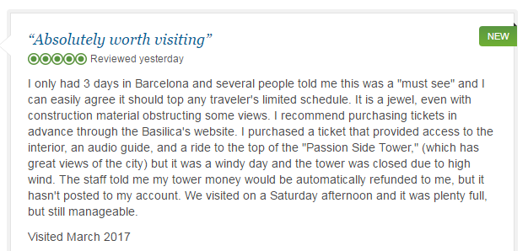
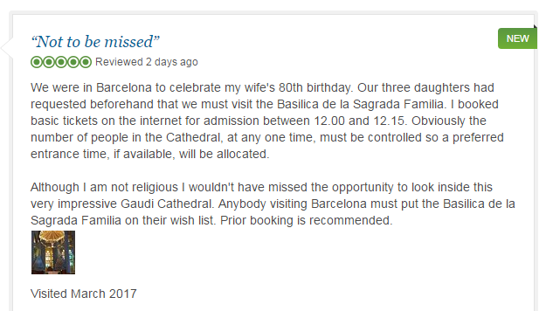
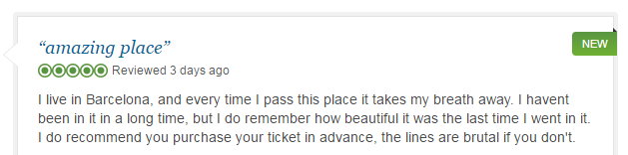

https://www.tripadvisor.co.uk/Attraction_Review-g187497-d190166-Reviews-or60-Basilica_of_the_Sagrada_Familia-Barcelona_Catalonia.html#REVIEWS

